resume
SRISTY MRINAL
Mail:sristymrinal11@gmail.com
Contact:+91-9798671346
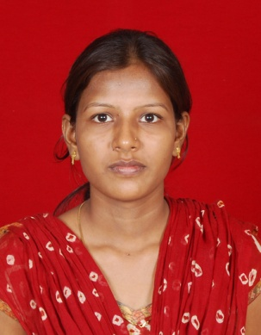

Objective:

To obtain a challenging position as an employee in a prestigious organization and to grow professionally by learning from the organization by giving my best.

Educational Qualification:
Year of Passing | Class | Institution | University/Board | Score
2013 | B.E – EIE | Sathyabama University, Chennai | Sathyabama University | 69%
2009 | 12th | B.L.P college, Masaurhi,patna | B.S.E.B | 56.33%
2006 | 10th | S.L.B high School, Makhdumpur,patna | B.S.E.B | 70.28%

Area of Interest:
.
- Industrial instrumentation
- Analytical instrumentation

Computer Skills/ Knowladge:

- Basic C Programming
- MS-Office
- ERP

Technical Qualification

- Obtained Post Graduate Diploma in Industrial Automation (PGDIA) from Technocrat Automation Pvt Limited (IAO Accredited), Chennai. With 3 months hands on practical experience in Industrial Automation Tools specializing in PLC, SCADA and VFD.

Technical Skills

- PLC (Programmable Logic Controllers) Programming languages such as LD(Ladder Diagram)
- Hands on Practical exposure in brands as Siemens,ABB (Asea Brown Boveri)
- SCADA (Supervisory Control & Data Acquisition) – Screen designing , PLC interface, Data collection & storage
- VFD (Variable Frequency Drive)
- Pneumatics & Field Instruments ( Control Valve, Sensors, Level Transmitters, Flow Transmitters, Temperature Transmitters, Pressure Switches)
- Knowledge in Panel wiring
- Knowledge in PID(Proportional Integral Derivative)
Acadmic project

Main Project:
Project Title: Tri-axis motion detection using MEMS for unwired mouse navigation system in the future generation machine.

Description: We designed a model using MEMS accelerometer to detect the user’s head movement in order to direct mouse position on the monitor.Also clicking events are generated by detecting complete eye blinking as a selection mechanism.

Experience

Working as a graduate engineer trainee in E&I department in monnet ispat and energy ltd.

Extra-curricular Activities

- Participated in many SPORTS in school level.
- Served as event organizer in various school level programs.
- Worked as coordinator in school as well as college fest.

Hobbies

- Travelling
- Watching TV program
- Cooking
- Curiosity to learn new things

Strengths

- Positive attitude
- Honest towards work
- Good team worker
- AdaptiveLeadership Quality

Languages Known

Sl No: | Language | Speak | Write | Read
1. | English | Yes | Yes | Yes
2. | Hindi* | Yes | Yes | Yes
* Mother Tongue

Personal Details

- Date of Birth : 14-12-1991

- Gender : Female

- Father’s Name : Mr. Mukesh Kumar

- Mother’s Name : Mrs. Madhuri Kumari

- Marital Status : Single

- Mother Tongue : Hindi

- Permanent Address : Vill- Kanauji, P.O- M.P Kachhuara, via-Rajendra nagar
Patna-16, Bihar

- Present Address : House no.-141,Panchwati colony,Boirdadar
Raigarh -496001,Chattishgarh

Declaration

I hereby declare that the above information is true to the best of my knowledge.

Place: Raigarh
SRISTY MRINAL

